[Back to Table of Content]

Chapter Six: Discovering A New Life

Amherst, in the Berkshire Mountains, is an intellectual, bustling, lovely town full of bookstores, winding streets, New England clapboard homes, and trees. We were met with a New England Fall splendor of leaves turning yellow, red, and orange and it was like entering into a painting. We rented an apartment in the University complex and I began my two jobs. My primary job was as a graduate student working towards a Master’s of Science and the second one was my assistantship which supported my family.
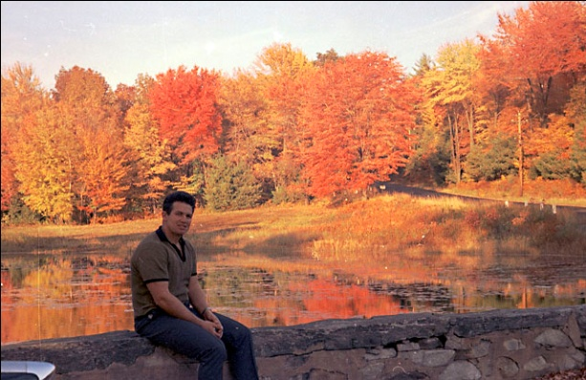
Amherst Massachusetts
The subjects I was assigned to teach were weight training and physical fitness. Since I had experience working in Physical Therapy during my Army service at Tel Hashomer hospital in Israel, I also was assigned to help in the Physical Training room. Here, the University athletes were treated for injuries or required joint taping prior to their practice. Furthermore, I assisted several professors grading the under-graduate student exams periodically during the semester.
One day shortly after arriving at the University, I was walking near some sports training fields and saw several athletes throwing the Discus. My heart beat a little quicker as I watched the throwers and saw the discus land on the green grassy surface. After studying one of the athlete’s throws, I walked over and commented to him that he was not holding his arm at the proper height. On his next throw, he raised his arm, and the discus went farther. He was quite thrilled at this improvement in his throw.
He asked me, “How did you know that?”
I replied that I was also a discus thrower.
This comment seemed to provide more credibility to my coaching comments. “How far can you throw?” he asked me.
“One of my better throws was 192 feet.” was my reply.
“Wow,” he exclaimed. Soon the other discus throwers gathered around and I began demonstrating my throwing technique.
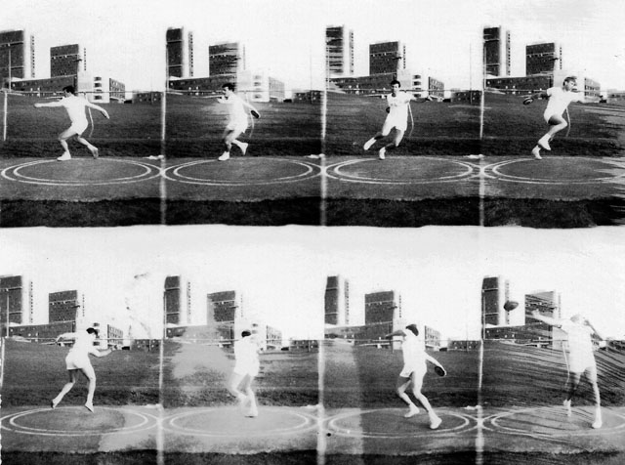
My Demo Throw at the University Track and Field
Suddenly, another man joined our discussion. He introduced himself to me as the University’s Head track coach, Ken O’Brien. He had happened to overhear our conversations and was happy to have an opportunity to meet me. “You must be Gideon Ariel, the Olympian from Israel” he said. “Someone told me that you would be here at the University in the Fall and I was looking forward to the opportunity to meet you and pick your brain about various events.”
I was pleased at the recognition and to have the opportunity to meet the Head Coach. I had hoped that there would be an opportunity for me to maintain my discus throwing skills. I responded that I was indeed Gideon Ariel and confirmed that I had competed in the Rome and Tokyo Olympics as a discus thrower. The athletes chatted enthusiastically with this news and immediately plied me with questions. The result was the coach offered me a job as his assistant for the throwing events. I would continue teaching my other subjects for my assistantship, but I was more than happy to become involved with the Track Team.
School started in September and my courses were stimulated me more than I had expected that they would. I especially enjoyed the classes in Physiology, Anatomy, Kinesiology, and Statistics. My intention was to finish the M.S. degree in only one year rather than the two years that some of the other students were taking. For that I had to register for 24 credit hours in addition to a 6 hour research project.
The department of Exercise Science at the University of Massachusetts did not have a Ph.D. program at that time. So my plan was to finish the M.S. degree in Exercise Science and then apply to another University to work toward a Ph.D. I had not decided where that school would be or exact what I intended to study, but I was confident that by the end of the year, both would be answered.
Yael was extremely dissatisfied with my plan. She wanted me to go back to Israel after I finished the Master’s degree and start working to support our family. In fact, she had spent most of the cross country drive from Wyoming to Massachusetts trying to convince me to return to Israel as soon as possible. Yael saw no value in education. Her plan was for us to go back “home” where we could live by our “hands” rather than by our “minds.” In fact, throughout her life she was quite successful as a jewelry maker and a clothing designer. Both of these careers were viable for her since she was able to combine her creative mind with her highly skilled hands.
But my priorities were education first and family second. Perhaps this is an abnormal choice for some people, but it seemed perfectly logical to me at that time as well as now when I reflect on my decision. “How can you have a comfortable and productive life with a healthy family without a first class education?” I asked. “For me, the choice is to be a leader or a slave. As a slave you work all your life for others and you will always have a boss. I would prefer to be the boss.”
Clearly, these were extremely contradictory concepts for life. It was not a situation where one choice was right and the other one was wrong. It was a deeper divide with little or no place for compromise. Yael and I began having serious problems. We had never been particularly compatible. She had traveled to the United States because I had been so lonely in Wyoming and I was obsessed with her beauty. Yael had agreed to meet me in Wyoming, initially expecting it to be just for a short three-month visit. Had the Brody family not pushed for the marriage, she probably would have returned to Israel and that would have been the end of it.
However, at this point, I had lived in America for three years, had traveled around the country as an athlete representing the University, successfully graduated with honors, and had worked during the summers vacations. I definitely wanted to continue my studies in the US. I was undecided about what I would do after completing my education, but there was nothing that I would allow to interfere with this educational path. I still saw Yael as the most beautiful woman in the world, but I was not willing to sacrifice my education for her.
On the other hand, Yael had not attempted to broaden her horizons of interests or her skills. She continued to maintain the status quo that she had brought from Israel in 1963. We began to argue constantly with many traumatic scenes, as befits a young couple who both had unstable upbringings and were frightened and ambivalent about ourselves, our daughter, and our future. Eventually, Yael moved to her own apartment in Amherst taking Geffen with her. We struggled to find some accommodation with each other. After all, we shared a daughter, but this connection could not bridge the huge gulf in interests, future plans, or even our daily schedules. It was an awkward situation which persisted for several years until it ended in divorce.
Meanwhile, my studies at the University were dramatically opening my eyes. Ironically, my course in Kinesiology, with Dr. Robert James, was the same text book that I had devoured at Wingate College, The Mechanics of Athletics by Geoffrey Dyson. However, Dr. James’ focused more on the scientific aspects that we had at Wingate. For the assigned class project to calculate different movement parameters, I selected several of the Track and Field events.
Professor Ricci, a renowned physiologist, was my professor in physiology. For the first time I began to more thoroughly understanding the basics of muscle action. I realized that regardless of what technique I used to coach my athletes, it still came down to the basics that their arms and legs must be moved by a force created by the muscles. We studied the basics of all the chemical changes which occur in the muscles, tendons, and ligaments, and other tissues in the body. Technique alone is not the equation for success. It is the coordination of physiology and biomechanics which creates an optimum performance. I wanted to be able to measure these parameters quickly and efficiently.
Professor Harry Campney was the main advisor for my Master’s thesis but Professor Ricci had received a substantial grant of money to conduct research projects. I had some ideas for my thesis project which I presented to Dr. Campney. He agreed with the general idea but suggested that I try to enlist Dr. Ricci’s interest particularly since there would be some additional funding. Dr. Ricci enthusiastically agreed to be a committee member for my Master’s Degree thesis project. Now came the tricky part. I needed to choose a subject and it was obvious that Dr. Ricci would want me to conduct some experiment in physiology, since this was his area of expertise. But my interest was more in the mechanical parts of the analysis of movement. I wanted to know more about quantifying things such as why raising or lowering the discus throwers arm produced throws of different lengths. These discus throwing results could not be due to a physiological reason but must have something to do with the angles of the arms or legs or maybe even more complicated interactions. My dilemma was how to combine both aspects of movement, the physiological and the mechanical, in order to satisfy Professor Ricci.
In one of the physiology courses with Professor Ricci, we had covered a subject that included a very famous physiological test of performance efficiency. This test had been devised at Harvard University. Johnson et al. (1942) had formulated a “step test,” known today as the Harvard Step Test (HST). The test was presented as a method of judging the general and cardiovascular fitness of the individual. Each test subject was required to step on and off a stool 20 in. high (50.8 cm) at the rate of 30 steps per minute for a total time of five minutes. At the conclusion of the test, the subject sat down and the first heart rate was taken after one minute of rest, then after the second minute, and finally after the third minute. Each of the recovery pulses was counted for 30 seconds. The fitness index was a ratio of the sum of the three pulse counts and the duration of the exercise in seconds according to the formula outlined in the original report.
For my own particular interest, it seemed that this Step Test would fulfill both scientific aspects. The Physiology portion measured the heart’s response to stress and the mechanical portion evaluated the person’s step. One of my specific thesis questions related to the height of the step and how the knee joint angle affected the performance. Obviously, shorter people need to flex their knees more and therefore exert more effort than taller people. I proposed the study to Professor Ricci and he agreed with me that this would be an excellent topic for my Master’s Degree Thesis.
I conducted the test utilizing two different steps. One step was set at the fixed distance described by the original Harvard University researchers. Then I devised an adjustable step which I could change for each individual. In other words, this step could be adjusted so that the subject would always begin the test with his knee at a right angle. This specialized step is shown in the following photo:
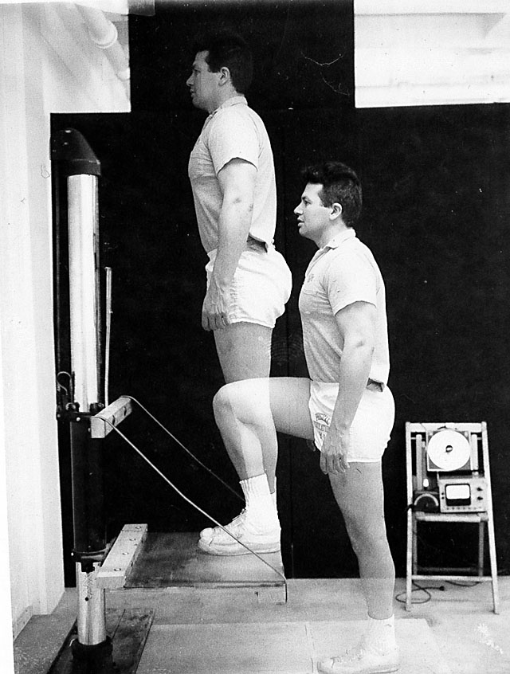
I utilized 30 volunteer subjects from among my various classes. After analyzing the data, my study revealed that short people have to exert much more effort to perform the standard Harvard Step test than the effort required of tall people. In other words, shorter people produced higher heart rates resulting from the increased amount of work required to complete the test. The standard Harvard Step test was only accurate in reflecting fitness levels for people who began the test with their knees positioned at right angles. It was unfair and biased against any individual whose knee joint was not at the right angle at the beginning of the test.
After conduction the test, analyzing the results, and presenting the conclusions, I submitted the study to my Thesis Committee. They were quite impressed with both the Thesis question and the manner in which I addressed the discrepancy in the original Harvard test. They perceived my study as novel work and cheerfully awarded me my Master’s of Science degree in 1967.
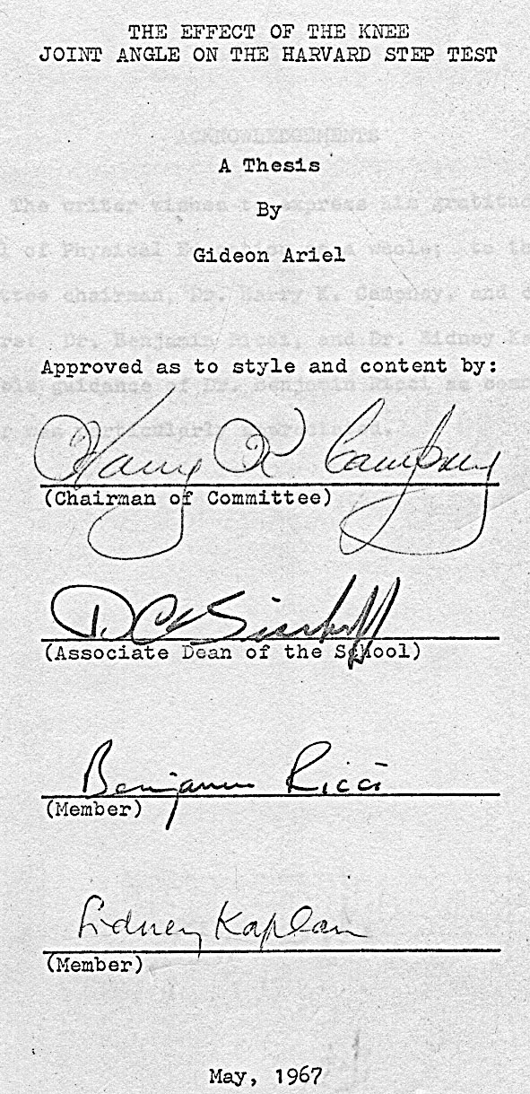
Dr. Ricci was proud of me and my accomplishments during the previous year. He asked whether I would be interested in publishing my thesis study in an international, refereed journal. He assured me that if I published the results of my Thesis, it would be easier to obtain a scholarship to another university to pursue a doctoral degree. Naturally, my answer was an enthusiastic “yes”.
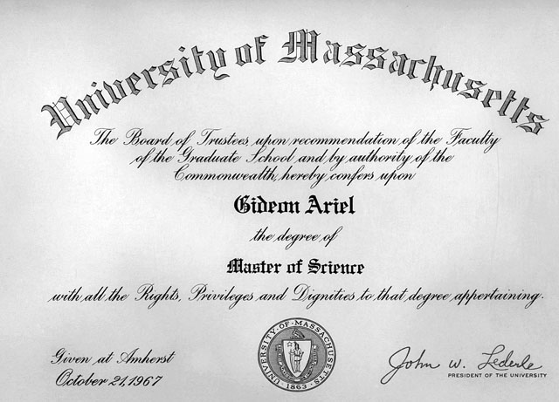
My Master’s of Science Degree Certificate
Coincidently, Professor James was leaving for his sabbatical year and he asked me if I would run his Therapeutic center at the University. This position would allow me to earn extra money and it was also perfect timing. I could remain at the University of Massachusetts, earn some money while I published my thesis study, and take some additional courses in engineering and mathematics. Thus, when school resumed in the Fall of 1967, I would have a whole new set of goals and tasks. I could hardly wait.
But, I also needed to earn some money during the intervening summer months. I was able to obtain a job as a camp director at Camp HES (Hebrew Educational Society) which was located in upstate New York in the Catskill Mountains. I was hired because I was an Israeli and this was the only Jewish camp on a large beautiful lake which was shared by about five other, non-Jewish camps. Every year, Camp HES experienced a variety of pranks perpetrated by the neighboring camps. The HES Camp Board of Directors in New York City believed that an Israeli would know how to handle this yearly plague of unwarranted practices. In anticipation of the pranks I had been warned to expect, among the various counselors that I hired, were some of my Israeli military friends.

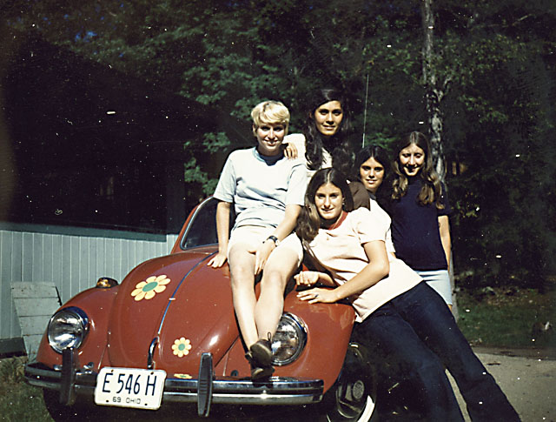
Some of my Counselors and my beetle
One of the favorite, tried and true, pranks was to sneak under cover of darkness and cut the connections which held our swimming rafts securely in place. Without the proper tethers, our rafts would float down the lake into the river. Not only was it time consuming and arduous work to retrieve the rafts, all our water activities were disrupted for days.
One of the counselors I hired with this situation in mind was Dany Tal who had spent his Israeli military service as a frogman. Another counselor was Yaron who served in the Israeli Army as a paratrooper. In addition to being very popular counselors with the kids attending the camp, they were part of my “counter-terrorism squad”. The day finally arrived when all of the kids went down to the lake for the water activities to stare in shocked silence at the empty waters. Our rafts had been cut just as they had been every year before. A few of our counselors now had to find the rafts, wherever they were down the lake or into the river, catch them, and tow them back to camp. This would take days.
That night, Dany, Yaron and I mobilized our resources and went into action. Under a black sky, Dany, with his frogman’s gear, rode in the boat with Yaron and me. At each dock, Dany slipped into the dark water and severed the ropes holding the dock in place. We quietly circled the lake “liberating” 24 rafts. The next morning’s calm was filled with the loud and angry shouts. Around the lake were gesticulating and screaming people at every camp. Boats from each camp were in on the lake with people trying to locate rafts and shouting at one another through bullhorns. It was a collective disaster and filled the beautiful bucolic area with noise and commotion.
The local police set up a meeting with all the camp directors. I wore my yamulke and introduced myself to all the other camp directors. After a long discussion about the rafts being cut, I mentioned that our rafts had also been cut the day before and I wondered if perhaps it was the same group who had cut the other camps’ rafts. There were no conclusions drawn that day. Likewise, there were no leads on the perpetrators of the vandalism. Therefore, all of the camp directors returned to our individual camps and things continued normally until the morning of July 5^{th.}
On July 5th, one of my counselors discovered that a swastika had been painted on the Rabbi’s car. This was another “annual” event which the Board had warned us would happen. Although we could not actually see the faces of the people in the other camps, most assuredly, they were laughing hysterically at this amusing, to them, prank.
That night, about 3 AM, Dany, Yaron, and I once again went into action. We sneaked into each camp and dismantled the wheels from the cars. The wheels were thrown into the lake and all of the bolts were carefully immersed in jars of jelly and left on picnic tables in plain view.
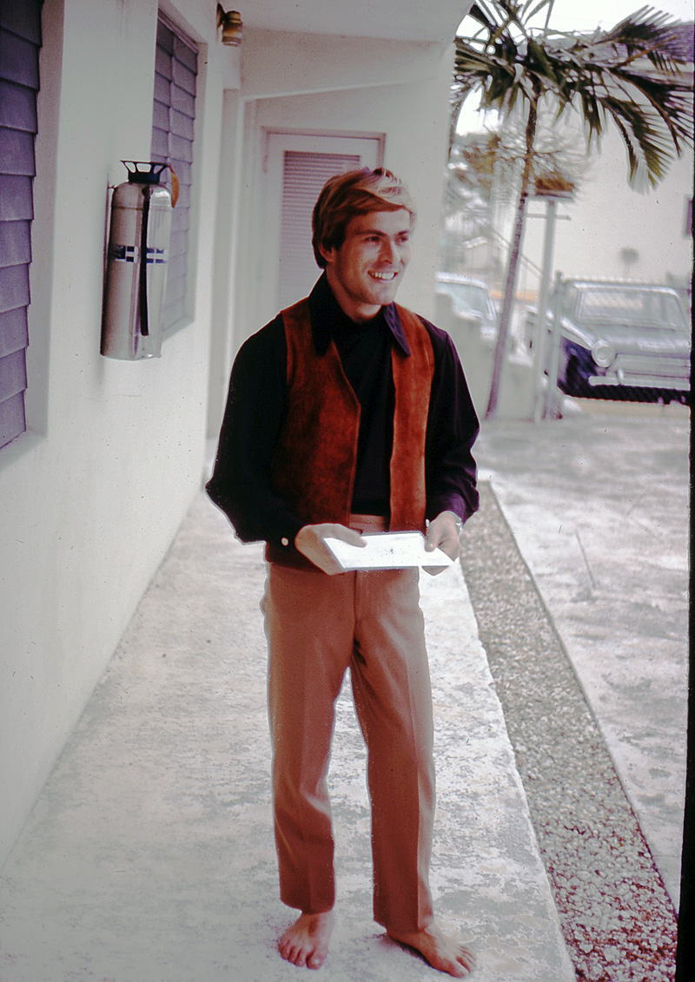
Danny Tal – The Frog Man
The following morning, the police once again requested that all the camp directors meet. After a long discussion about who could have been responsible for this crime, I addressed the meeting wearing my customary yarmulke. “Perhaps you are all aware that we are a Jewish camp. First, our rafts were cut and then, miraculously, yours rafts were cut soon afterwards. Then someone committed this terrible act of painting a Swastika on the Rabbi’s car. I think this must be an act from God. In fact, God came to me at night and warned me about what was to happen. Therefore, I have no reason not to believe that God has answered our prayers.” After this quite speech, I sat back and waited. Each of the directors and the police chief stared at me as if I had dropped out of the sky. They looked at each other in silence and then the meeting was concluded with no other ideas presented regarding the cars losing their wheels to the lake.
The summer progressed without further incidents. Our rafts never were cut and the Swastika was never again drawn on the Rabbi’s car. The children enjoyed the rest of the unblemished summer and I was rehired as Camp Director for the next year.
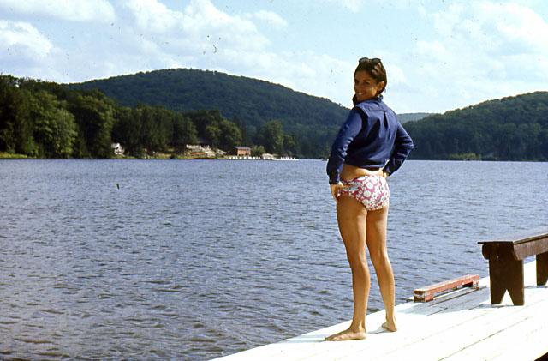
The lake at the Camp
After my summer camp adventures of 1967, I returned to Amherst for a new and totally different school experience. This was the first time since my Army days, that I was not the student but more like a teacher in several of my new roles. I was to run Dr. James’ Therapeutic Center which was primarily a physical therapy experience. Because of my work at the Tel Hashomer hospital in Israel where I had worked with wounded and recuperating soldiers, I was easily able to work with injured and recovery athletes. I was back in the physiology laboratory conducting experiments based on my Master’s Thesis funded by grant monies from Professor Ricci. I also attended engineering and math courses and I continued to work with Coach O’Brien and the Track and Field team.
After a few months, I submitted my experiments to the Ergonomic Journal for publication. This is a referee journal which means that every study presented is reviewed by a peer group. The scientists who read each submitted publication are selected according to their individual academic and scientific expertise. In this way, each study is examined by someone familiar with the topic rather than someone in physics trying to make an evaluation of an experiment in psychology. This allows better comprehension and decision making based upon the merit of a submitted study’s content. In addition, the reviewer is not told who has submitted the proposed publication in order to avoid blatant bias against the writer. Fortunately, my publication was approved and published.
My days were full of work and study. I still had time to train with the discus and work out with the athletes in the exercise room. I filled and mailed many applications to universities throughout America in hopes of finding a good school to pursue my doctoral studies. Dr. Ricci was quite helpful with this effort. With his help and my excellent academic record, I was able to receive a full scholarship in the Anatomy and Physiology department at Indiana University beginning in the Fall of 1968.
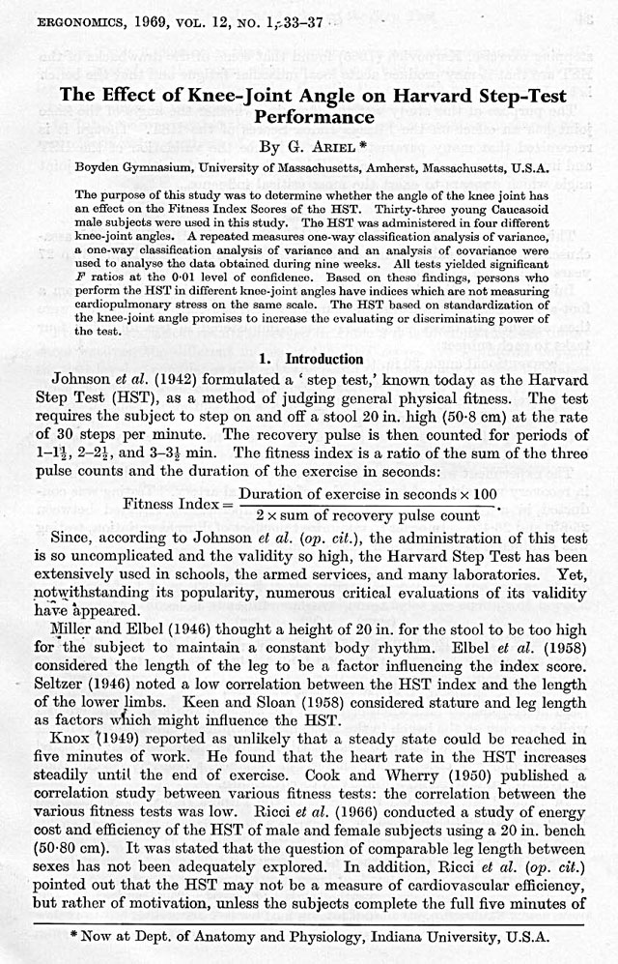
Before the semester began in Indiana, I returned to Camp HES for the summer. Fortunately, the annual pranks, which had previously plagued this camp, were not repeated. I guess the message from God had carried over the winter into the camp season! There were the usual mixture of Israeli and American counselors and the summer began with beautiful skies, warm weather, and fun.
Every year, I was invented some crazy idea to trick and entertain the campers. This year, I had read that there would be a total solar eclipse. Of course, it was actually going to occur in the South Pacific, but for my purposes, this was irrelevant. The first order of business was to organize the counselors and the sequence of events. We “created” a completely imaginary injury to someone who slept with their watch on their arm. Because of this “injury”, I announced that everyone would remove their watch before bed and leave them on the small tables next to their beds. After about two weeks of removing their watches before bed, none of the campers gave this ritual any thought. It became an automatic night time routine.
For the next phase of the scheme, I arranged for the local shop to print some newspapers, filled with all of the accurate local news, to include an article concerning the solar eclipse which would occur. Of course, I and the staff had decided the day that the reported solar eclipse was to occur! The day that the newspapers were delivered to the camp, all the counselors read the articles as did many of the campers. Imagine my joy when some of campers discovered the article about the eclipse that would occur at 7 o’clock the next morning. That evening after dinner and prior to the evening events, I announced that since tomorrow morning there would be a total solar eclipse, we would have to begin our day in the dark. However, we would still have all of the usual activities, although it would be dark for the ones at the beginning of the day.
That night, after the campers had fallen asleep, the counselors quietly crept through the campers’ bedrooms, moving the time on the watches forward by four hours! I had enlisted the corporation of the cook and other staff members as part of this “eclipse” event and they were thrilled to be part of this potentially hilarious hoax. At the real time of 3 am, the alarms set for 7 am went off all over camp. The bugler blew the wake-up call and in the solid, blackness that is found in the woods away from city lights, the campers arose. We proceeded with all of the normal early morning activities including the flag raising ceremony. All in the darkness of the total eclipse. At breakfast, I asked if any of the campers had been awake to see the moon cross in front of the sun. If so, would they please describe the event for those of us who had missed it. There were many hands in the air and each of these campers described with graphic details the drama of seeing the moon passing across the face of the sun and the day going into night. Suddenly, one of the campers shouted that the sun was coming up! Now, as dawn rose around the camp, the total solar eclipse was no more. As realization of the trick that we had played spread around the dining room, there were cheers of joy and uncontrollable laughter, especially from the campers who had “seen” the eclipse take place before their eyes.
Camp continued for the rest of the summer with the normal fun and games. As usual, our sports teams lost every game they played during the annual “All Camps Olympics”. Losing every year was always a low point. But, I tried to overcome these losses with other activities for the kids within Camp HES like the “eclipse” event.
Following my summer adventures, I set off for Indiana University to pursue a doctorate. The Department of Anatomy and Physiology also provide a path for those who wanted to become medical doctors. I was very intrigued with the idea of becoming a physician. Perhaps this is an option that I might seriously pursue. After all, I was a good Jewish boy and, secretly in my heart, I harbored the idea that this would prove my worth to my father. I tried to imagine myself as a doctor as I drove across New York State to Bloomington, Indiana, the home of the famous Hoosiers.
I began my studies as well as involving myself with the Track and Field team. The Head Coach, Mr. Bill Perin, had been an Olympic coach at one time. I very much wanted to go to the Olympics in Mexico City which were to be held in October that year. This would be my third Olympic games but this time I would be a spectator rather than a participant. As luck would have it, Coach Perin and I were able to travel to Mexico City and secure tickets for the Track and Field events. Luckily for me, Coach Perin was able to persuade the Olympic officials to let me stand on the field so that I could film the events unimpeded by fences, flags, or the spectators’ heads in the cheering crowds in the stands. I had taken a movie camera to record the best performers and hopefully I would be in the right place at the right time. I planned to analyze the film as I had been doing during the two years at the University of Massachusetts. This was the first time in the Olympic history that a scientist was allowed to collect real time data at the Olympics. Prior to my appearance, the only films collected on the field were for television coverage or historical productions like those produced by the great film makers Bud and Cappy Greenspan.
The choice of Mexico City to host the Olympics was controversial because of the city’s high altitude, 7585 feet or 2,300 meters. The high altitude proved an advantage in such explosive events as short distance running, jumping, throwing, and weight lifting. But the rarified air had the opposite effect on those competing in endurance events since it was difficult to breathe.
I was lucky enough to capture Bob Beamon World Record breaking performance in the Long Jump. His landing, at a spectacular distance of 29 feet and 2.5 inches, was an amazing world record which stood for 22 years. It was interesting to watch Bob Beamon complete his jump, look at the scoreboard, and then display little emotion. However, after he was told the converted distance from meters into feet for his jump, he was enthusiastic with joy and elation.
The overall experience for me was exhilarating and, as I was able to enjoy the Games from the spectator’s viewpoint, it was far less stressful than my previous experiences. I also had an opportunity to reunite with many of my old Israeli friends and coaches and was invigorated by seeing and sharing their Olympic experiences as well as chatting about friends and places in Israel. It was bittersweet to part with old friends but I needed to return to my studies.
I returned to Indiana, ready to work, and started my second Anatomy course. This particular class was designed for those students in the pre-med program. I was not aware that the class included a laboratory section in which we had to dissect dogs. The first laboratory session where we sliced into a dog’s chest and removed the beating heart was enough for me! I love dogs too much for that kind of experimentation. In addition, there was too much blood involved for me to seriously consider continuing on a medical career. I immediately terminated my medical career.
At this point, I had to consider what other options were available for me to pursue. The most logical step seemed to be to return to Amherst and study there while I searched for another program. As I drove east, back to Massachusetts, I decided to look at the program possibilities at Kent State in Ohio.
Kent State had an excellent program of Exercise Physiology under the guidance of Dr. Golding. Dr. Golding had already heard about me from Dr. Ricci and offered me a scholarship. Since I already knew that the University of Massachusetts still had not begun a Ph.D. program in Exercise Science, I decided to continue my studies at Kent State.
Of course, one my first destination was to the Track Coach with offers to assist training the athletes. I was able to help some of the team members to improve their results. In fact, several of them eventually were members of the American team.
To supplement my assistantship, I worked at the local Jewish school where I taught Jewish culture. I was more serious about teaching the children about Israel and the culture of my homeland. Since this was a school setting rather than a summer fun camp, it was unnecessary for me to creat “eclipses” or provide other forms of entertainment.
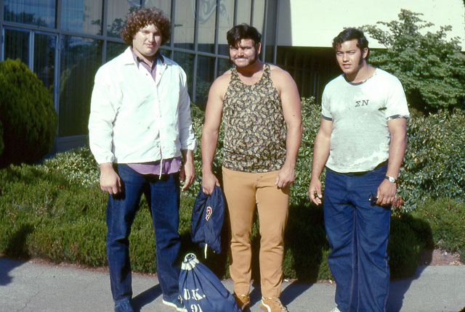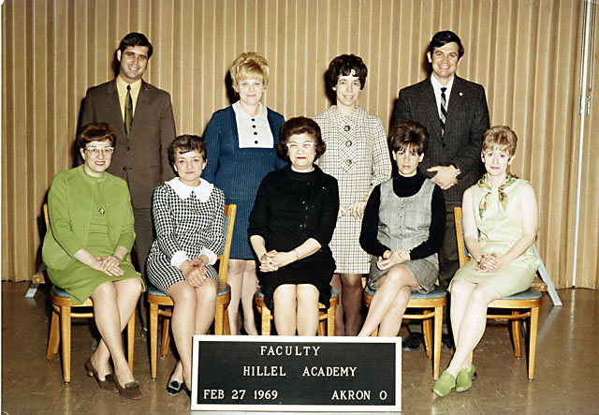
Three athletes that made the American and French Team and my Jewish school teaching staff
Shortly after the first quarter ended at Kent State, I received a telephone call from Professor Ricci. He was excited to tell me that the Governing Board of the University had approved the Ph.D. program in the Exercise Science at the University of Massachusetts. The first doctoral candidates would be admitted beginning in the Fall semester of 1969. His first question was whether I would like be a member of that first doctoral study program. In addition, he verified that there would be assistantships available for those students who needed them. This was wonderful news and I responded with great enthusiasm that I was more than interested. I told him that I would plan to return to Amherst at the end of the second quarter classes at Kent State. I would complete the necessary paperwork for the Fall semester. Then I would work at a camp in the summer before the classes began in September.
That summer, I was once again the Director at Camp HES. The weather that year was particularly rainy. Needless to say, it is not as much fun to go to summer camp and have torrential rain forcing everyone indoors. The counselors and I were continually stretching our creative minds to invent active and fun things to do. Finally, after nearly two weeks of rain, I decided to contact the local weather bureau to see if I could find some guidance regarding the forecast for the near future. I hoped to gain some insight so that we could try to find indoor things for the campers to do. I listened with increasing relief to the description of the weakening low pressure center would be moving Eastward during the night and would clear to partially cloudy skies by noon. Then the extended forecast was for a period of warm and sunny summer weather for a few weeks.
I could not let this opportunity pass without capitalizing on the weather. The counselors and I put our heads together to find an appropriate end of this seeming endless monsoon of rain. Finally, we decided to have a “Flood” to rival Noah.
The next morning the rain continued to fall. After the breakfast had been eaten and the dishes cleaned up, I announced with great sadness that the entire World was flooded and our camp was the last place still on dry ground. This was a repeat of Noah’s flood and we should prepare for the worst. The children began to cry and ask what were we going to do. The counselors moved around the room with paper, pens, and bottles complete with stoppers. We told them to write their thoughts and dreams, their names and address, and any final wishes. We assured them that someday in the distant future, these bottles would be opened by archeologists and they would discover what had happened to our camp.
After the children had written their messages to the archeologists of the future and stuffed them into the bottles, we arranged for each group of campers to drag all of the canoes from the lake up onto the basketball court. Then all of the campers, with their paper-filled bottles, climbed into canoes to await the rising waters. The counselors and I would walk around among the canoes and murmur words of encouragement. Suddenly, the sun began to peak out from behind one cloud with a hint of blue sky nearby. As the sky became brighter and the sun shone through the remaining clouds, all of the counselors and I made a circle around the canoes and began to sing and dance. The song and dance are a famous Israeli melody called “Mayhem, mayhem” which means “water, water”. As we cheerfully sang and danced, the campers slowly realized that the whole “Flood” was another one of my creative “events”. They climbed out of their canoes, wiping away tears, and joyfully joined the circle of dancers. That evening after dinner, those campers who were interested were allowed to read their “message” aloud to the group. They were hilarious notes and the whole dining hall rocked with laughter. To this day, I am sure that none of those kids will ever hear that specific song and not smile while they explain how they survived the “Flood”!
Soon thereafter, a new problem developed. On the signup sheet for the dance and drama activities, too few campers had registered to act in the annual camp play which was performed near the end of the camp season. How to solve this problem? I announced at dinner, that we at Camp HES were very privileged to have been one of the camps selected for the Hollywood directors and producers’ tour. The group of Hollywood representatives would watch our play and would most likely select one or more of our talented actors ánd actresses for future roles in Hollywood. Unfortunately, all of the roles were currently filled, but perhaps because of this fantastic opportunity, maybe the dance and drama counselors would be able to expand the number of positions if anyone else were interested. The play that had been selected for that summer was “Fiddler on the Roof”. Miraculously, by the next morning, the signup sheet was filled with willing campers.
As the summer drew to a close, I arranged with six of my friends to arrive in big, fancy cars to “judge” our talented players. They arrived on the appointed day wearing dark sun glasses, scarfs tied around their necks, and clipboards for note taking. They were quite serious as they sat at the front of the audience, comprised of all of the campers and most of their parents, and watched “Fiddler” performed. Afterwards, the producers interviewed the performers and made many notes. With great encouragement, these Hollywood directors drove away leaving many pleased people. Needless to say, I was one of the most pleased at the success of the dance and drama portion of Camp HES.
Following the summer at Camp HES, I drove to Amherst to begin the Ph.D. program at the University. My job that year, 1969, was as a graduate assistant for physical education classes. In addition, I created an “Exercise for your Life” class which was open during the lunch hour for everyone in the university. I usually had 30 to 40 men and women, of all ages, attending this class. I was quite pleased that few people dropped out and, in fact, the roster swelled slightly as the semester continued. In addition, I worked with Ken O’Brien and his Track and Field Team. I focused primarily with the field events including discus, shot put, hammer, and the jumping events.
In addition to my assistantship work, I had a full academic load of classes. One was a statistics course with a wonderful Canadian professor named Dr. Gail Oakland. His background studies in Canada had involved wheat and other grains which were surprisingly not that different from human beings when you examine them statistically. In class one day, Dr. Oakland asked a question that hung in the air unanswered for an elongated pause. Finally, one girl raised her hand and answered the question perfectly, as Dr. Oakland proudly noted. Since I had absolutely no idea how she had known the answer, I approached the girl after class. I inquired how had she known the answer since I had studied and not found anything like that. She stared at me without smiling, rudely asked if I knew where to find the library, turned on her heel and walked away. I was shocked.
Another course I took that first semester was Motor Integration with Dr. Walter Kroll. Dr. Kroll was the only man who had an office in the Women’s’ Physical Education building. He had a large office downstairs and an even larger laboratory for his research. Apparently, he was the only male faculty member who could get along with the teachers in this building. His field of interest involved understanding how the nervous and the muscular systems worked together. Actually, I was more inclined to the mechanical portion of human performance, but you need the nervous system to control how and when the muscles pull on the bony levers to produce movement. I wanted to ask Dr. Kroll a question that had been discussed in class the preceding day so I walked all the way across the campus to his office. It was a long walk since the powers that be had put the men’s gymnasium where I worked as far away a possible from the women’s building where Dr. Kroll worked.
Dr. Kroll’s office door was slightly ajar. I knocked on the door, but there was no answer. I peeked inside to make sure he was not there and pondered my next step. His laboratory was just down the hall, so I decided to check there. I knocked loudly on the door and nothing happened. After a brief pause, I knocked again much harder this time in case Dr. Kroll was at the back of the laboratory. Suddenly, the door was flung open to reveal the same girl that I had seen in Dr. Oakland’s statistic course. I immediately asked it Dr. Kroll was there. The girl frowned and nearly sliced me into pieces with her fierce “I don’t know. I am not his secretary. Can’t you read?” and slammed the door in my face! At this point, I read the large, colorful poster sized sign on the door which read “TESTING DO NOT DISTURB”. Oops.
One of my independent projects was to analyze the Olympic athletes I had filmed in Mexico City. I was particularly interested in Bob Beaman’s jump since it was a World record and one that was probably not going to be broken for a long time. I had a close friend, George Dales, who was the Head Track and Field Coach at the University of Western Michigan in Kalamazoo. George was a very intense person and devoted to the athletes and coaches in these sporting events. In addition, he was the head of the International Track and Field Coaches Association and published a Quarterly Journal for this organization. His goal was completely focused on how to help coaches train their athletes and how athletes could better understand their events. This meant that the articles that he published were for his target audience not for the aggrandizement of the scientist writing the article. George has worked tirelessly with this goal for as long as I have known him and he has not slowed down as he is now in his late eighties. He is almost as strong now as he was then and there will be more stories about him. However, with regard to the Bob Beamon study, this was one of my first of many articles published in the Track and Field Quarterly Review.
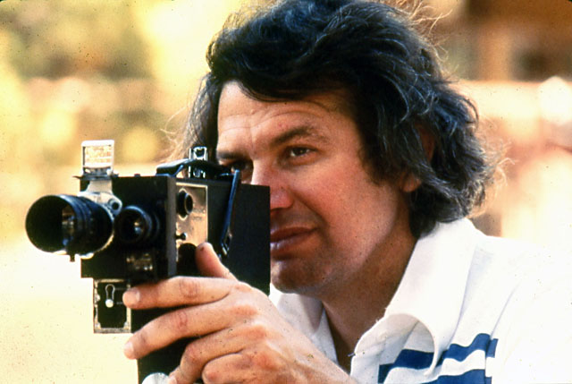
At the Mexico Olympics 1968 20/20 Show on this Analysis
During the Spring semester of 1969, I happened to be in the hall outside of the weight lifting room. Just as I had my hand on the doorknob, I heard a shout from a friend of mine, Jim Selidas. He was waving at me and there was a girl walking just behind him in his shadow. Jim said that he wanted me to meet his friend, Ann Penny, who had heard so many stories about “Crazy Gideon” but insisted she did not know who that was. I was stunned to see the same girl that had refused to answer my statistics study question and who had slammed the lab door in my face. Based on her facial expression, I could tell that she did not remember these encounters. We politely shock hands, chatted for a few moments, and then I had to begin my class. Little did I know that we would meet again.
Classes concluded at the end of May, so I set off again for Camp HES for the summer. Each year there was a kind of Camps Olympics for the camps around the lake. All the camps competed in different sports such as basketball, swimming, and various running events. Our Jewish camp always had terrible results. The other camps beat us mercilessly in every event. I had decided that this year things would be different.
Submissions to attend the camp arrived at the beginning of the summer. I took the opportunity to meet and select the 100 kids who I wished to be campers for that summer. Only kids who excelled in basketball or soccer or could run fast or swim like fish were accepted. My goal was to choose 100 “Spartans” for camp that summer. I separated them, not by age, but by sport. I only hired counselors who could coach sports. We trained every day for hours in preparation for the last week of camp when the Camps Olympics would take place. I minimized the other normal camp activities in order that there would be more time to train. For example, instead of studying about Jewish prayers, the Rabbi coached the soccer team.
About a month before the Camp Olympics, I organized the annual Maccabean Games. This year I wanted the event to be especially meaningful so that the campers would be even more inspired to continue to train for the Camp Olympics. A few mornings before the big event, I announced I had arranged for the Prime Minister of Israel to come to our camp and officially preside over the opening Ceremonies. The campers were ecstatic with pride and joy. They prepared songs to sing and flags to wave for him. We purchased a large floral arrangement to present to him when he arrived.
The day dawned with beautiful sunny weather. The campers were dressed in their sporting clothes and eagerly awaited the arrival of our important visitor. About ten o’clock, a large black limousine drove around the corner of the administration building and the campers burst into song and waved their flags enthusiastically. When the door opened, the Prime Minister stepped out of the limousine in formal wear with dark glasses protecting his eyes from the sunlight and a black hat on his head. He graciously accepted the flowers and waved at the campers and counselors. He was escorted to the place of honor and in halting English read the proclamation opening the Maccabean Games of 1969.
Shortly after the first events began, I announced that the Prime Minister had to leave to conduct some important official duties. The campers waved and cheered as his limousine disappeared around the building. The Prime Minister then returned to his real job as the owner and director of the local funeral home.
In 1969, there were no cell phones. People did not spend their lives calling and texting everyone all day and night as is common practice now. In fact, the campers were not allowed to call their parents unless there was an emergency. Apparently, one of the counselors went into town after the Games, had a meal at the local diner with friends, and from there the tale spread. The only phone in camp was located in the administrative office, so I was quite surprised to receive a call from the Chairman of the Board of the Camp in distress over my failure to tell him that the Prime Minister of Israel had been at Camp HES. As I described what had happened and who the Prime Minister actually was, we both had quite a laugh about the whole episode.
Finally, the biggest event of the summer was about to take place. All of the campers from the surrounding camps congregated at one of the camps for the annual Camp Olympics. As usual, our kids faced snide comments and smiles of anticipated victory over them. I confess to being quite nervous because of our past history of failures. Just because we had trained for the whole summer did not mean that we would be successful. As the day progressed, each event ended with Camp HES campers proudly standing on the victory stand in first place. There was first place in basketball, then soccer, then the track events. Finally, we took first place in each of the swimming events. I was so proud that we had won every event. The kids and the counselors were crying and I had tears in my eyes. All of us enjoyed these victories which had eluded the Camp HES campers for so many years before.
Then I was fired. Why? The committee in New York discovered that although the campers may have become excellent athletes, they had not become particularly great Jewish scholars. It seemed that skipping the Jewish education part and the early morning prayers in order to train for sports was unacceptable to the parents and the Board. My career as Camp Director at HES ended.
But in spite of the end of my career as a camp director, there was a silver lining. During the summer, I shared the camp director’s house with several of the counselors including Dany, the frogman, who had returned every year since the infamous raft-cutting events. Dany had met stunning beautiful Israeli girl, named Esti, at another camp. As the summer progressed, I watched their relationship evolve. Although I did not discuss the situation with Dany, it appeared that he did not really care for Esti and, in fact, lacked respect for her. I was much more of a gentleman with women. One hot day, late in the afternoon when we had a few hours free before dinner with the campers, I offered to drive down to the local ice cream parlor to buy milkshakes for everyone. This offer was met with enthusiasm and a list of everyone’s favorite flavor. When I returned with a box filled with milkshakes, I neatly wrote a message on Esti’s cup, “You are so beautiful.” I carefully handed her the milkshake so that she would immediately see the message. At first she had a puzzled look and then smiled. As the summer progressed, Esti parted ways with Dany and became my girlfriend. When the summer ended, she came to live with me in Amherst.
This residency was short lived, however. Although Yael and I had lived separately for three or four years, Yael was not willing to let go of me. During that same summer, Yael and Geffen had gone to Israel. When she learned about Esti and me, as the gossip mill runs across miles of land and oceans, she was outraged. She visited Esti’s family in Israel and informed them that she would never divorce me. She made it very clear that Esti could never be my wife.
Esti’s family was so distressed by this news that an uncle was dispatched to Amherst to discuss the situation. She was persuaded to return to Israel and wait to see what happened next between Yael and me. Needless to say, it is very difficult to have a long distance relationship so we gradually drifted into our own separate lives.
Esti and I have remained good friends for many years, however. In fact, once when I was visiting Israel, Esti wanted me to meet her fiancé. It was surprising to find that he was one of the injured soldiers that I had rehabilitated during my Army time at Tel Hashomer hospital. We continue to meet whenever I travel to Israel or she is in the United States. Esti is a wonderful person and still beautiful.

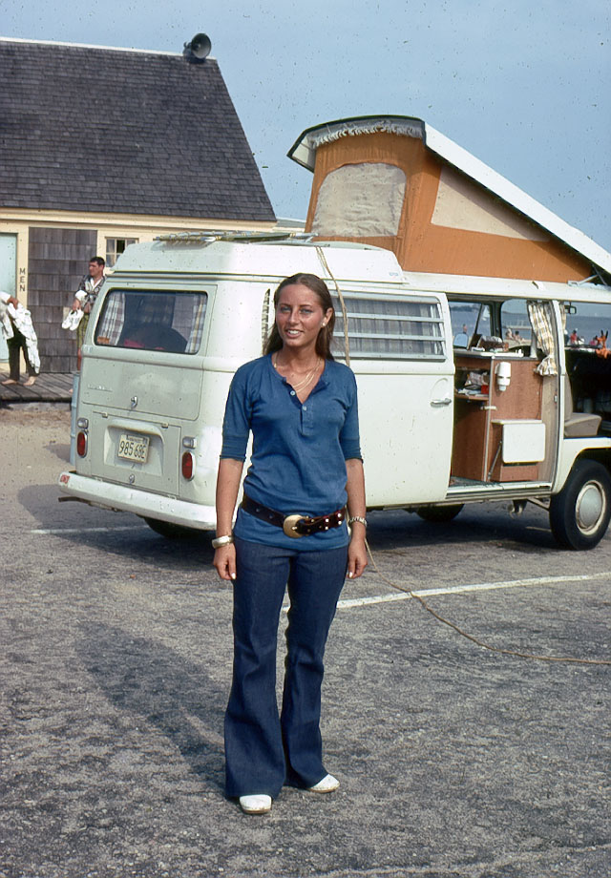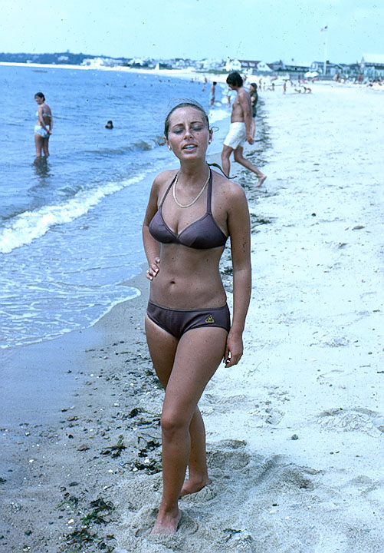
Esti and my Camper at the beach in Massachusetts

Academic life, working as an assistant, training in the weight room, and working with the Track and Field team filled my days. I focused on these things and pushed Esti into the back of my mind. Fortunately, I was extremely busy and, over time, became obsessed with my work. About this time, I discovered a new and fantastic friend.
[Back to Table of Content]

